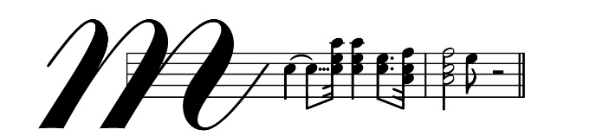
The McCormick Opera Award
Presented by
Perpetual Guardian and Auckland Opera Studio
Entries open 3rd June, 2019 and close 6pm, Friday 26th July, 2019
All Competitors must complete the application form and send it to the Event Administrator, The McCormick Opera Award, PO Box 28245 Remuera, Auckland 1541 or email the completed application form to aucklandoperastudio@gmail.com

NOTE:
1. Print clearly and ensure all accompanying information for entry is attached/included.
2. Ages – the competition is open to all New Zealand singers or New Zealand residents (see conditions) aged between 18-32 years on July 26th, 2019.

COMPETITOR:
First Name .............................................................. Surname .....................................................................
Address ..............................................................................................................................................................
City / Town...............................................................
Email ................................................................................
Date of Birth .................................................................... Age at 20 July 2018 ...........................................
Phone .................................................................... Mobile .........................................................................

OFFICIAL ACCOMPANIST:
Name: Rosemary Barnes
Address: 29 Fancourt St, Meadowbank, Auckland 1072 Phone: 021 1839734

ITEMS:
- Title .....................................................................................................................................................................
Approx. length ....................................................................................................................................................
Composer ...........................................................................................................................................................
- Title .....................................................................................................................................................................
Approx. length ....................................................................................................................................................
Composer ...........................................................................................................................................................
- Title .....................................................................................................................................................................
Approx. length ....................................................................................................................................................
Composer ...........................................................................................................................................................
- Title .....................................................................................................................................................................
Approx. length ....................................................................................................................................................
Composer ...........................................................................................................................................................
- Title ....................................................................................................................................................................
Approx. length ....................................................................................................................................................
Composer ...........................................................................................................................................................
- Title .....................................................................................................................................................................
Approx. length ....................................................................................................................................................
Composer ...........................................................................................................................................................

An entry fee of $20 NZD must accompany this application or be paid directly into the Auckland Opera Studio account 12-3125-0174710-00 and be clearly identified with name, initials and the words ‘Aria fee’.)
Please confirm which method of payment you have used: Online Payment Payment Enclosed

Signature of Entrant: ..........................................................................................................................................
Name: ...................................................................................... Date: ..............................................................
(Please Print)
Please initial each page of the entry conditions attached and attach a photocopy of passport for proof of resident status and date of birth.
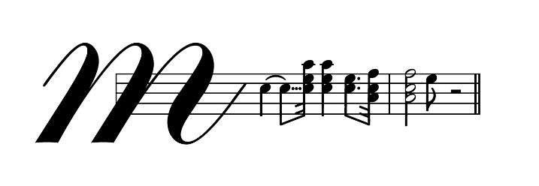

Event Administrator
The McCormick Opera Award,
PO Box 28245 Remuera, Auckland.

